Week 8 - Scheduling Tasks Assignment - Instructions

Windows Instructions

Step 1 –

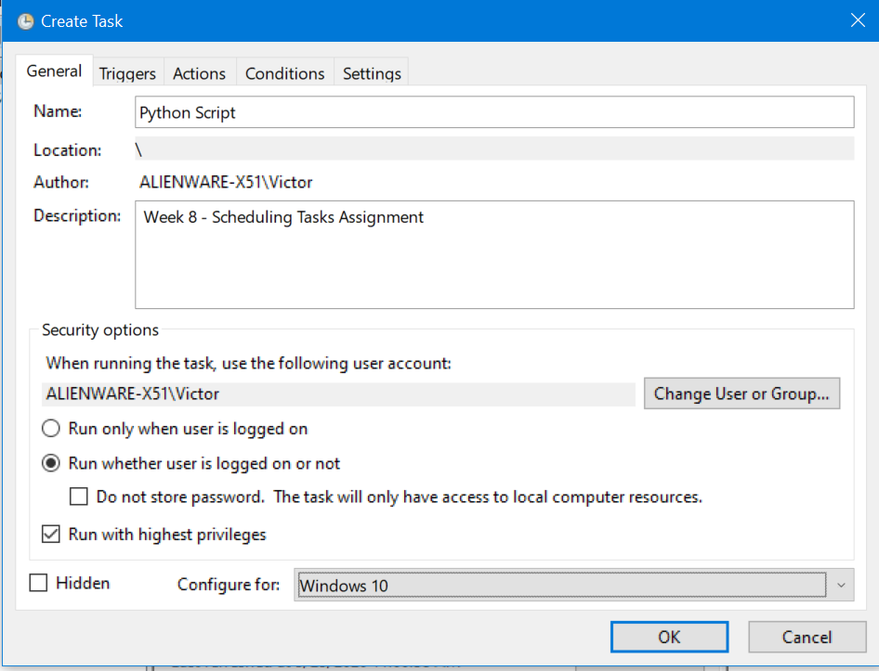

Step 2

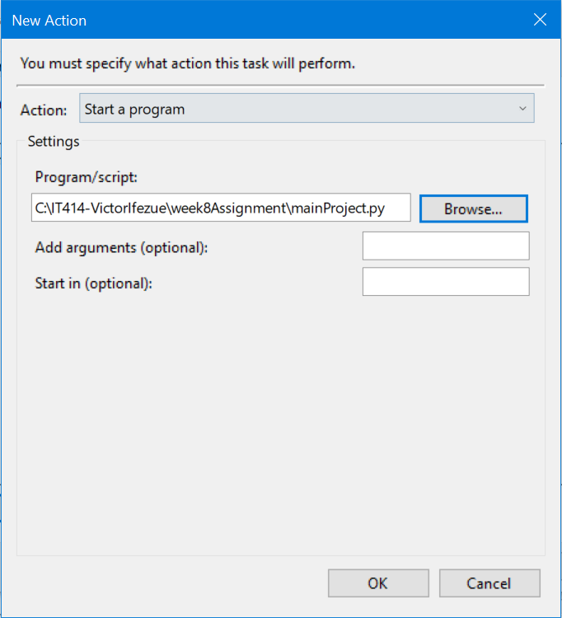

Step 3 –

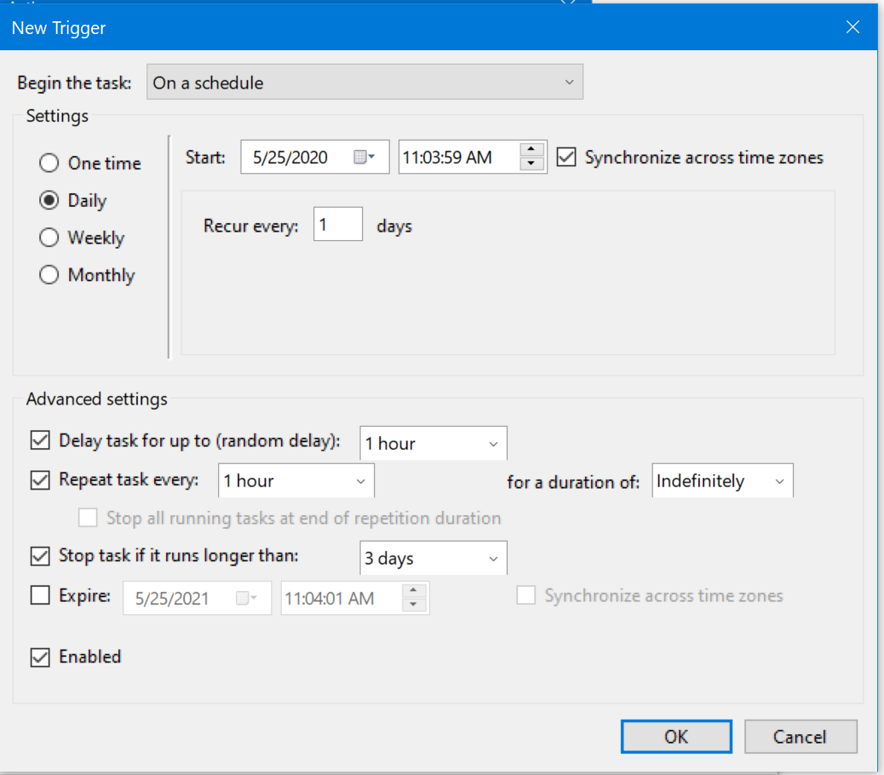

**Linux –**

**\* * * * * C:\IT414-VictorIfezue\week8Assignment\mainProject.py >/dev/null 2>&1**

  <string>python /IT414-VictorIfezue/week8Assignment/mainProject.py </string>

**Mac**

<?xml version="1.0" encoding="UTF-8"?>

<!DOCTYPE plist PUBLIC "-//Apple//DTD PLIST 1.0//EN" "http://www.apple.com/DTDs/PropertyList-1.0.dtd">

<plist version="1.0">

  <dict>

    <key>Label</key>

    <string>com.example.app</string>

    <key>Program</key>

  <string>python /IT414-VictorIfezue/week8Assignment/mainProject.py </string>

    <key>StartInterval</key>

    <integer>14400‬</integer>

  </dict>

</plist>